Exp. 2. Simulation of Density of States of Quantum Well Structure
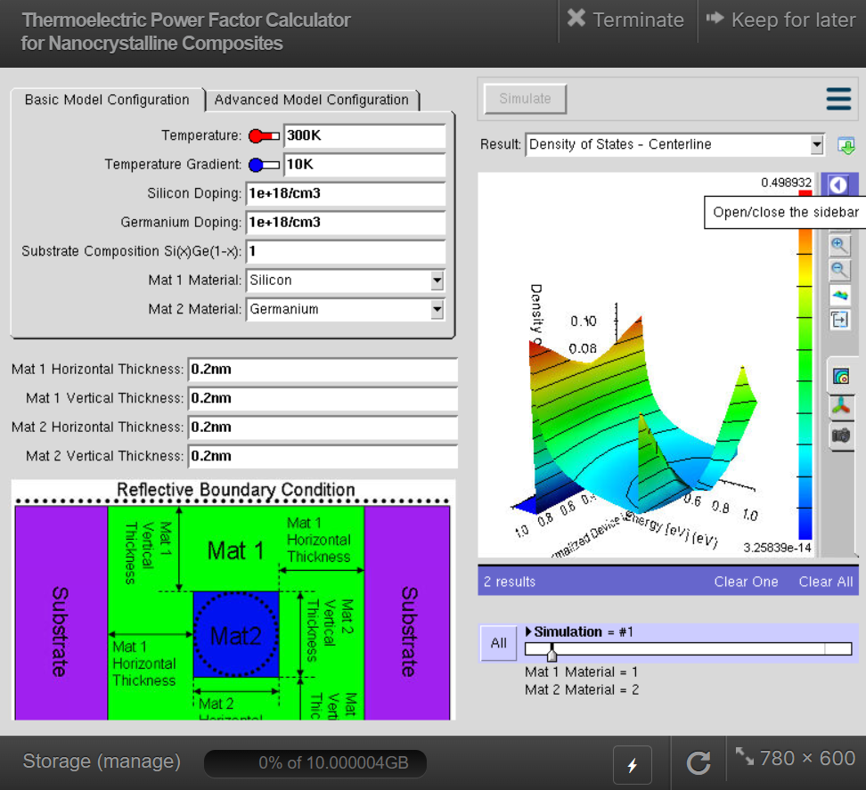
Case Study 1: Simulate the density of states of quantum well of thickness 0.5 nm
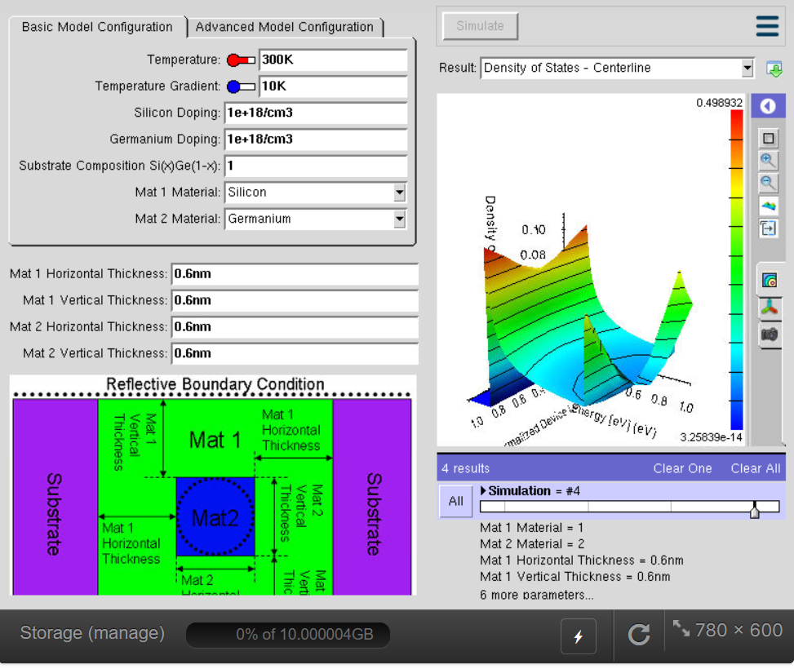
Case study 2: Case Study 2: Simulate the density of states of quantum well of thickness 0.6 nm

Exp. 3. Simulation of Energy States of Quantum Dot using NanoHub
Case Study 1: Simulate the energy states of cylindrical quantum dots of X=15 nm, Y = 10.5nm
and Z = 8 nm.
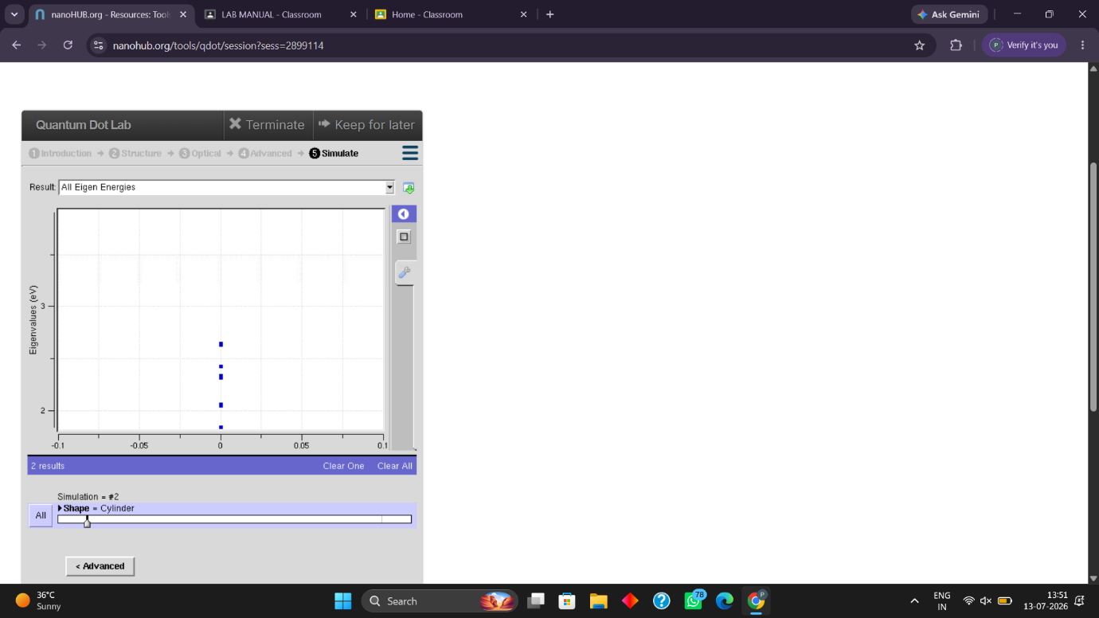
Case Study 2: Simulate the energy states of two layer cuboid quantum dots
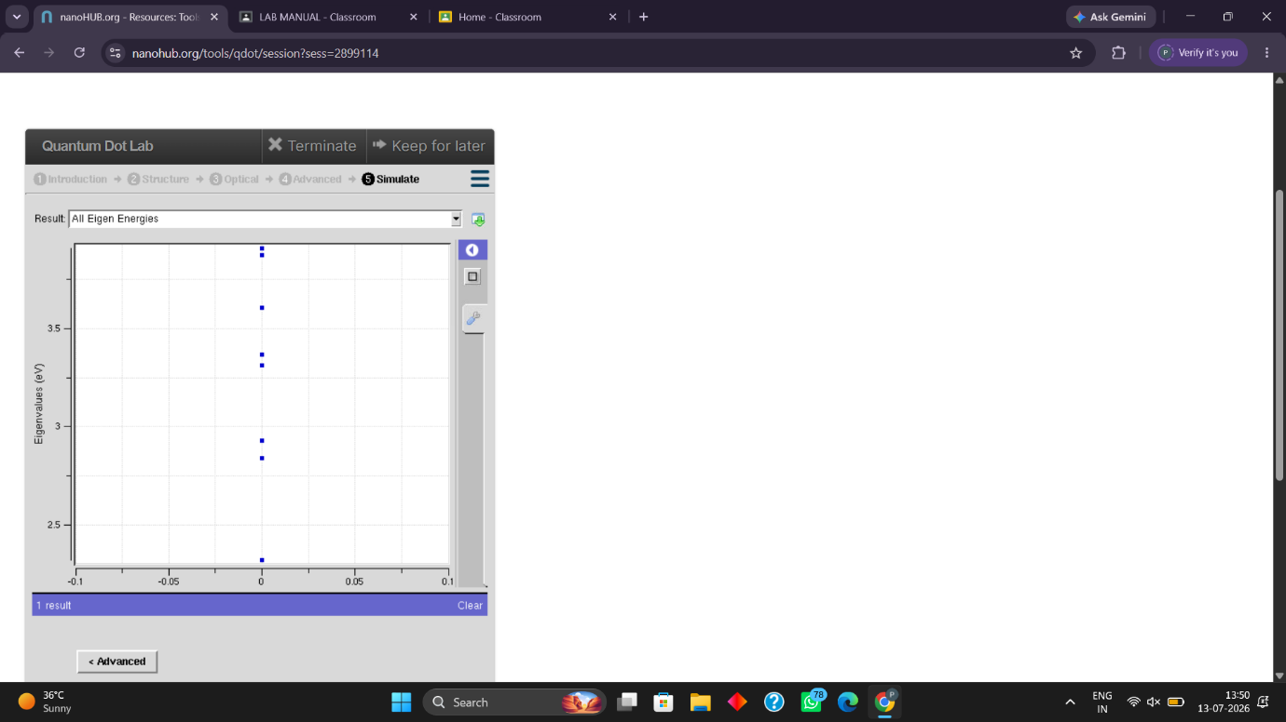

Exp. 4. Kronig Penney Model
Case Study 1: Simulate the output for Triangular well
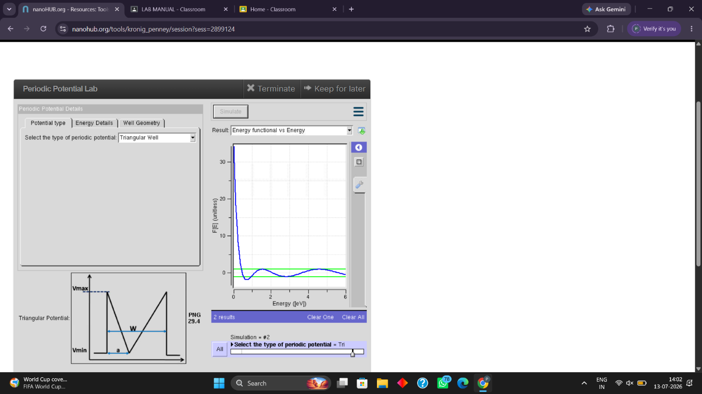
Case Study 2: Simulate the output for Sinusoidal Potential
